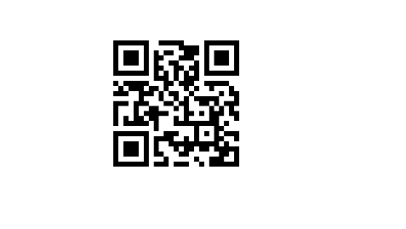**Dr. Cassandra Quave**

Lab Website: etnobotanica.us │ Author Website: cassandraquave.com

Podcast: foodiepharmacology.com │ Newsletter: naturespharmacy.substack.com

Email: cquave@emory.edu

**Short Bio**

Dr. Cassandra Quave is a medical ethnobotanist, scientist, inventor, and entrepreneur. She is the Director of the Herbarium and Professor of Dermatology and Human Health at Emory University School of Medicine, where she also serves as Associate Dean for Research Facilities. In 2023, she was named to an endowed position as the Thomas J. Lawley, MD Professor of Dermatology.

Dr. Quave earned a B.S. in Biology and Anthropology from Emory University (2000) and a Ph.D. in Biology from Florida International University (2008). As a John Simon Guggenheim Memorial Foundation Fellow, Fellow of the National Academy of Inventors, Honorary Member of the Garden Club of America, and Fellow of the Explorers Club, Dr. Quave is at the forefront of plant-derived natural products discovery. Her pioneering work has led to the issuance of eight U.S. patents, with several pending, and she has co-founded two biotech startups, both dedicated to translating natural product discoveries into innovative therapeutics.

Quave is the recipient of the American Herbal Products Association (AHPA) Herbal Insight Award and the American Botanical Council James A. Duke Excellence in Botanical Literature Award. In 2024, she was named a CNN Champion for Change. She currently serves on the boards of the Society for Investigative Dermatology, the American Botanical Council, the Royal Society of Chemistry journal *Natural Product Reports*, and the Beneficial Plant Research Alliance.

Dr. Quave has authored more than 100 scientific publications, two edited books, twenty book chapters, and her award-winning science memoir, *The Plant Hunter: A Scientist’s Quest for Nature’s Next Medicines*, which was named one of the best nonfiction books of 2021 by Kirkus Reviews. Her work has been widely covered by *The New York Times Magazine*, *BBC Science Focus*, *National Geographic*, NPR, PBS, and CNN.

Dr. Quave is a passionate science communicator and has been recognized with the National Academy of National Academies of Science, Engineering, and Medicine Award for Excellence in Science Communication. She has authored pieces for the *Wall Street Journal* and *Washington Post* and hosts the Foodie Pharmacology podcast and shares scientific insights via her YouTube channel (Teach Ethnobotany) and Substack newsletter (Nature’s Pharmacy). She provides consulting and research contract services to a variety of industry partners, from Fortune 100 companies to startups. Her work bridges traditional medicine and modern science, inspiring innovations across the sectors of dermatology, health, and natural product development.